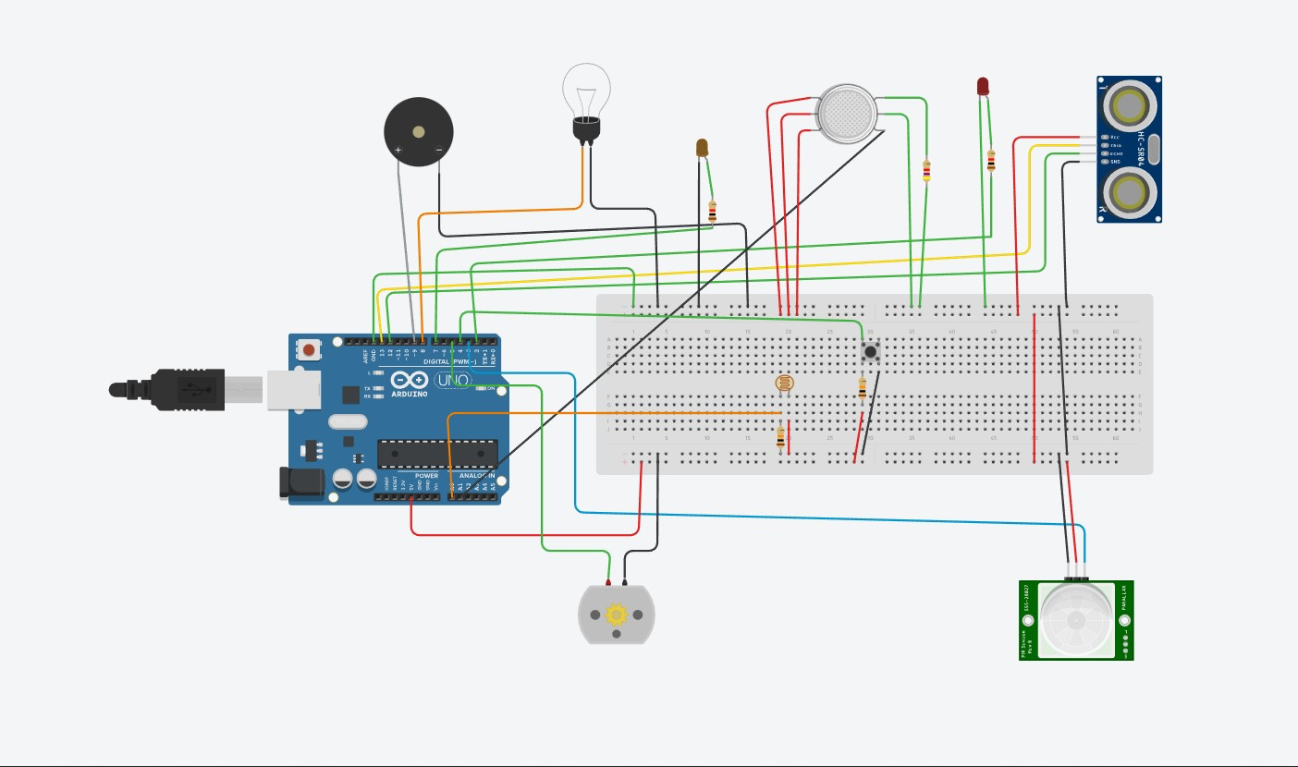

SOURCE CODE :

//LDR sensor-------------------------------------

int sensorReading = 0;

//LDR sensor-------------------------------------

//Ultrasonic sensor-------------------------------------

int inches = 0;

int cm = 0;

int triggerPin = 13;

int echoPin = 12;

int defult = 0;

long readUltrasonicDistance(int triggerPin,int echoPin)

{

pinMode(triggerPin, OUTPUT);

digitalWrite(triggerPin, LOW);

delayMicroseconds(2);

digitalWrite(triggerPin, HIGH);

delayMicroseconds(10);

digitalWrite(triggerPin, LOW);

pinMode(echoPin, INPUT);

return pulseIn(echoPin, HIGH);

}

//Ultrasonic sensor-------------------------------------

//Gas sensor-------------------------------------

int adcPin = 0;

int adcValue = 0;

float v;

float rs,ppm;

int buttonState = 0;

void setup() {

//LDR sensor-------------------------------------

pinMode(8, OUTPUT);

pinMode(A0, INPUT);

Serial.begin(9600);

//LDR sensor-------------------------------------

//Ultrasonic sensor-------------------------------------

pinMode(2, OUTPUT);

cm = 0.01723*readUltrasonicDistance(triggerPin, echoPin);

defult = cm;

Serial.print(defult);

//Ultrasonic sensor-------------------------------------

//PIR sensor--------------------------------------------

pinMode(3, INPUT);

pinMode(9, OUTPUT);

//PIR sensor--------------------------------------------

//Motor------------------------------

pinMode(5, OUTPUT);

pinMode(4, INPUT);

//Motor------------------------------

pinMode(7, OUTPUT);

pinMode(A1, INPUT);

}

void loop() {//########################################################################

//LDR sensor-------------------------------------

sensorReading = analogRead(A0);

if(sensorReading < 900){

digitalWrite(8, HIGH);

}else{

digitalWrite(8, LOW);

}

//LDR sensor-------------------------------------

//Ultrasonic sensor-------------------------------------

cm = 0.01723*readUltrasonicDistance(triggerPin, echoPin) ;

if(cm < defult){

digitalWrite(2,HIGH);

delay(50);

digitalWrite(2,LOW);

}else{

digitalWrite(2,LOW);

}

//Ultrasonic sensor-------------------------------------

//PIR sensor----------------------------------

int value = digitalRead(3);

if (value == 1)

{

tone(9, 440, 1000);

}

//PIR sensor----------------------------------

//Motor---------------------------------------------

buttonState = digitalRead(4);

if(buttonState == 1){

digitalWrite(5,0);

}

else{

digitalWrite(5,HIGH);

}

//Motor---------------------------------------------

//Gas sensor----------------------------------

int sensor_gas = analogRead(A1);

if(sensor_gas >= 400){

digitalWrite(7,HIGH);

}

else{

digitalWrite(7,LOW);

}

//-------------------------------------------

delay(1000);

}